Project Design Phase Proposed Solution

Date | 02 February 2026
Team ID | LTVIP2026TMIDS24102
Project Name | Heritage Treasures: An In-Depth Analysis of UNESCO World Heritage Sites
Maximum Marks | 5 Marks

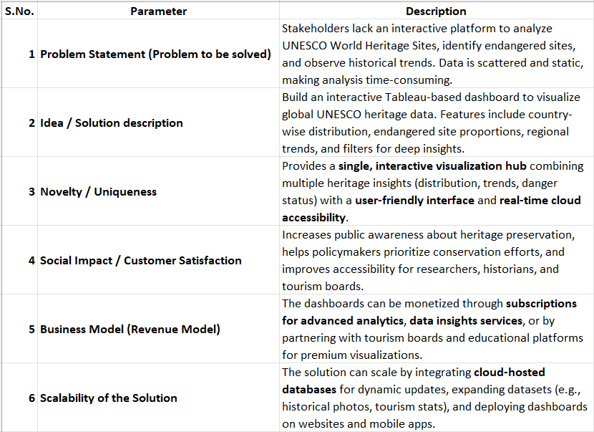
Proposed Solution:

